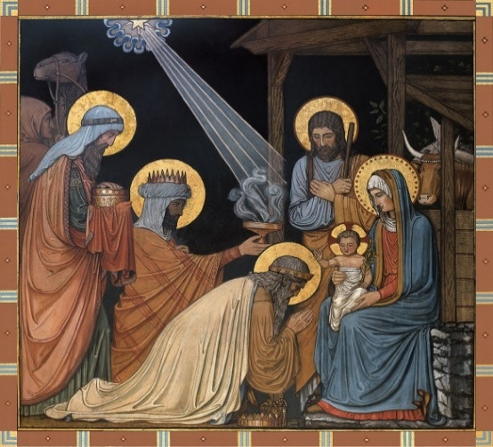
Parishes of St Bede, Clayton Green
and St Chad, South Hill
Parish News
The Epiphany of the Lord
5th January 2025

We are actively looking for a few more volunteers who would be able to take Holy Communion to parishioners in St Bede’s parish who are unable to join us at Mass. They might be in a nursing home or in their home. If you are willing to accompany one of our volunteers or drive them around that would be a help too. These roles need a DBS check which we guide you through. Please talk to Fr Mark if you would like to help. Volunteers from St Bede’s or St Chad’s are very welcome. Thank you.
There will be a meeting of the St Bede’s Social Group in the parish hall at 7pm on Monday 13th January. New members of this group which organises parish social events are very welcome to come along.
St Chad’s Reading Group will meet on 6th January, 2pm to 4pm in St. Chad’s Parish Centre. Books are provided from the County Library service and are available to borrow at each meeting. New members are very welcome.
St Chad’s Craft Group will restart on January 7th from 1.30pm to 3.30pm in St. Chad’s Parish Centre. Everyone is welcome, no skills or previous experience required.
A soup and sandwich lunch will be served on Tuesday 21st January at midday in St. Chad’s Parish Centre. Everyone is very welcome to come along. Please join us if you can.
We will be holding a “Hot Pot Supper post-Christmas Get Together” in St. Bede’s Parish Centre of on Saturday 1st February from 7pm. Save the date. More details to follow soon.
A Sauage Sizzle and Tea and Coffee will be served in St. Chad’s Parish Centre Sunday 19th January after the 9.15am Mass. Everyone is warmly invited to come along.
Poinsettias at Christmas
Thank you to everyone who made a donation to help us decorate our Churches for Christmas with Poinsettias. A card of dedication has been placed by each plant donated. Our flower team will let us know when it’s OK to take your plant home.
Preparation for First Holy Communion will begin in February in both our parishes. If you have a child in year 4 or above who would like to make their First Holy Communion next year who does not attend St Chad’s or St Bede’s primary schools, please get in touch and we will let you know when the preparation is starting.
Sr Dorothy and St Benedicte would like to thank everyone who came along and supported the coffee morning last month at St Bede’s in aid of CAFOD. £160 was raised for this good cause.
AN INVITATION TO A UNIQUE OPPORTUNITY
As you know, the process is underway for the appointment of a new Archbishop of Liverpool. You are invited to contribute to this process to have your voice heard. This is an exciting development in the life of the Church. There will be two meetings, held with the blessing of Archbishop Malcolm, on Thursday 16th January 2025 at St Mary’s Leyland, PR25 1PD (7.00pm – 9.30pm) and Saturday 18th Jan 2025 at St Margaret Clitherow Centre, L17 1AA (10.30am - 1.00pm). Each gathering will be the same – so only come to one of them. We will look at where we are as a diocese and our future development and we will consider the qualities needed in our future Archbishop. This is open to all members of our community here in the Archdiocese but we are asked to reserve a place if we want to attend. Please send us an email or phone the parish office in the New Year if you would like to be at the meeting.

Clayton Thursday Group will meet on 23rd January for over 60's to be held in St Bede's Parish Centre between 12.45 and 3.15 each Thursday.
Please come along.
Chair based exercise to improve strength, balance and flexibility. Starts again on 23rd January 2025 every Thursdays 11-12am, in St. Bede’s Parish Centre. If you want any more information contact Janet 07890165986
St. Chad’s and St. Bede’s Parish Centres are available to hire for use by groups and for some private functions. For enquiries about our rates and conditions of use for St Bede’s Parish Centre please call Aidan on 01257 271818 and for St Chad’s Parish Centre please call 07719718523. If there is no answer, please leave your name and telephone number and we will call you back.
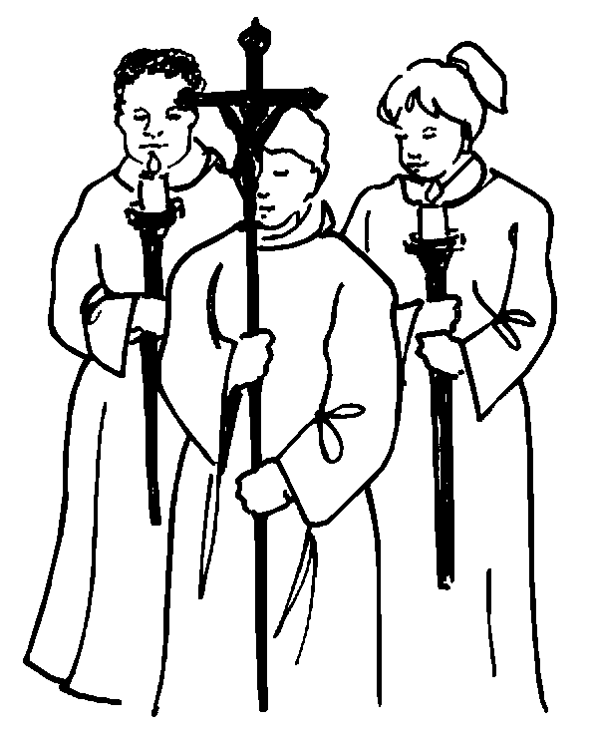
Altar servers – If you are in year 4 or older and would like to help with our altar servers team at weekend Masses, please let Fr Mark know. It’s a great way to learn about your faith and serve God and our parish family.

Non-perishable food and toiletries needed.
Food left at the back of St Chad’s
goes to support Chorley Help the Homeless.
Warm winter clothes are also needed, particularly for men.
Please leave donations at the back of St Bede’s Church for the Christian Community Larder. If you need help or would like to offer help they can be reached on 07762905978. Email:christiancommunitylarder@gmail.com

Fr Mark has been invited to help on a pilgrimage to Padua and Lake Garda 16th – 23rd May 2025, travelling with members of the Catholic Parish in Lydiate. There are spaces for some of our parishioners to make the pilgrimage too. It’s unfortunately very expensive. £1235 per person sharing half-board. If anyone would like more information or is interested in joining the pilgrimage, there is a poster giving the itinerary at the back of church or you can ask Fr Mark for the booking forms which are available in the sacristy of either church.

Dear friends,
thank you very much for the many cards, kind messages and gifts I received at Christmas. I am very grateful for the kindness and encouragement they show. It means a great deal to be remembered in this way. I do try to thank everyone in person but things can get a bit busy after Mass and I know I miss people. Please accept my sincere thanks and promise of prayers for you and your family in the year ahead.
God bless, Fr Mark

Parish Priest: Fr. Mark Beattie. Telephone 01257 460154
Deacon: Rev Simon Gilbertson
St Bede’s Church. 598, Preston Road, Clayton-le-Woods. PR6 7EB
01772 335209
St Chad’s Church. 237, Town Lane, Whittle-le-Woods. PR6 8AJ.
Parish Websites www.stbedesclaytongreen.co.uk and
www.stchads-southhill.org
Facebook page Look for “Parishes of St Chad and St Bede”
E-mail our parish office: stbedesclaytongreen@rcaol.org.uk
or stchad.chorley@rcaol.org.uk
or to Fr Mark privately m.beattie@rcaol.org.uk
The parish office is open on Tuesday, Thursday & Friday. 01772 335209

Masses this week
Saturday 4th January 6pm St. Bede’s Denis Ronson RIP

Sunday 5th January Epiphany of the Lord
9.15am St. Chad’s Parishioners
11am St. Bede’s Frank, Angela & Declan Collins

Monday 6th January 9.15am St. Chad’s Mary Beth Turner (RIP)

Tuesday 7th January 9.15am St. Bede’s Peter Ross

Wednesday 8th January No Mass

Thursday 9th January 9.15am St. Chad’s Special Intention

Friday 10th January 9.15am St. Bede’s David Seargent (RIP)

Saturday 11th January 6pm St. Bede’s Frank Hanley

Sunday 12th January The Baptism of the Lord (PW3)
9.15am St. Chad’s Marie Spicer & Andrew Sugden (RIP)
11am St. Bede’s Andrew Campbell

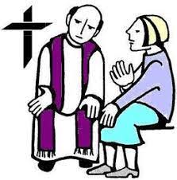
Confessions are heard in the confessional in St Bede’s church on Saturday evenings before the 6pm Mass from 5.30pm until 5.50pm. Or at any time on request.

Please pray for our sick and housebound parishioners
George Morris, Amy Greenhalgh, Thomas Hesse, Ray Briant, Robert Rainford, Brenda Wrightson, Maria Reynolds, Eileen Ainscough, Tony Miller, Katherine Yates, Marie Coleman, Virginia Hayton-Weed, Lawrence Eccles, Patrick Phillips, Joyce Campbell, Agnes Moss, Sandra Farrel, Diane Gunn, Shelagh Young, Liam Fogg, Dorothy Whittle, Gary Crook, Robert Hackeson, Marie Gamble and the residents of Highcliffe, Greenways, Brookside, Willow Bank, Meadow Bank Nursing Homes and Brookhaven.

